Name – Arshia Chandarki

Roll – CO3008

Lab assignment 3

CREATE TABLE Product (

ProductID INT PRIMARY KEY,

ProductName VARCHAR(50) NOT NULL,

Category VARCHAR(30),

Price DECIMAL(10, 2) NOT NULL,

Stock INT NOT NULL

);

CREATE TABLE Services (

ServiceID INT PRIMARY KEY,

ServiceName VARCHAR(50) NOT NULL,

Category VARCHAR(30),

Price DECIMAL(10, 2) NOT NULL

);

INSERT INTO Product (ProductID, ProductName, Category, Price, Stock) VALUES

(1, 'Laptop', 'Electronics', 1200.00, 50);

INSERT INTO Product (ProductID, ProductName, Category, Price, Stock) VALUES

(2, 'Smartphone', 'Electronics', 800.00, 100);

INSERT INTO Product (ProductID, ProductName, Category, Price, Stock) VALUES

(3, 'Desk', 'Furniture', 250.00, 20);

INSERT INTO Product (ProductID, ProductName, Category, Price, Stock) VALUES

(4, 'Chair', 'Furniture', 150.00, 30);

INSERT INTO Product (ProductID, ProductName, Category, Price, Stock) VALUES

(5, 'Headphones', 'Electronics', 200.00, 75);

INSERT INTO Product (ProductID, ProductName, Category, Price, Stock) VALUES

(6, 'Monitor', 'Electronics', 300.00, 45);

INSERT INTO Product (ProductID, ProductName, Category, Price, Stock) VALUES

(7, 'Printer', 'Electronics', 150.00, 25);

INSERT INTO Product (ProductID, ProductName, Category, Price, Stock) VALUES

(8, 'Sofa', 'Furniture', 700.00, 10);

INSERT INTO Product (ProductID, ProductName, Category, Price, Stock) VALUES

(9, 'Table', 'Furniture', 400.00, 15);

INSERT INTO Product (ProductID, ProductName, Category, Price, Stock) VALUES

(10, 'Camera', 'Electronics', 500.00, 5);

INSERT INTO Services (ServiceID, ServiceName, Category, Price) VALUES

(1, 'Web Development', 'IT Services', 1500.00);

INSERT INTO Services (ServiceID, ServiceName, Category, Price) VALUES

(2, 'SEO Optimization', 'Marketing', 500.00);

INSERT INTO Services (ServiceID, ServiceName, Category, Price) VALUES

(3, 'Graphic Design', 'Creative Services', 800.00);

INSERT INTO Services (ServiceID, ServiceName, Category, Price) VALUES

(4, 'IT Support', 'IT Services', 600.00);

INSERT INTO Services (ServiceID, ServiceName, Category, Price) VALUES

(5, 'Content Writing', 'Marketing', 300.00);

INSERT INTO Services (ServiceID, ServiceName, Category, Price) VALUES

(6, 'Consulting', 'Business', 2000.00);

INSERT INTO Services (ServiceID, ServiceName, Category, Price) VALUES

(7, 'Social Media Management', 'Marketing', 700.00);

INSERT INTO Services (ServiceID, ServiceName, Category, Price) VALUES

(8, 'App Development', 'IT Services', 2500.00);

INSERT INTO Services (ServiceID, ServiceName, Category, Price) VALUES

(9, 'Photography', 'Creative Services', 1000.00);

INSERT INTO Services (ServiceID, ServiceName, Category, Price) VALUES

(10, 'Data Analysis', 'Business', 1200.00);

SELECT COUNT(\*) AS TotalProducts FROM Product;

SELECT SUM(Price) AS TotalProductPrice FROM Product;

SELECT AVG(Price) AS AverageServicePrice FROM Services;

SELECT MAX(Price) AS MaxProductPrice FROM Product;

SELECT MIN(Price) AS MinServicePrice FROM Services;

SELECT ProductName AS Name FROM Product

UNION

SELECT ServiceName AS Name FROM Services;

SELECT ProductName AS Name FROM Product

INTERSECT

SELECT ServiceName AS Name FROM Services;

UPDATE Product

SET Price = Price \* 0.9

WHERE ProductID = 1;

DELETE FROM Services

WHERE ServiceID = 5;

SELECT ProductName FROM Product

WHERE Category = 'Electronics' OR Stock > 50;

SELECT ServiceName FROM Services

WHERE Category != 'Marketing';

SELECT ProductName FROM Product

WHERE Category = 'Furniture' AND Price < 500;

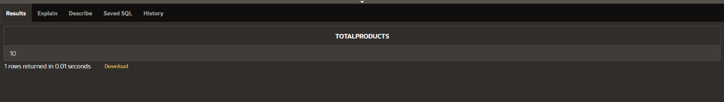

Count

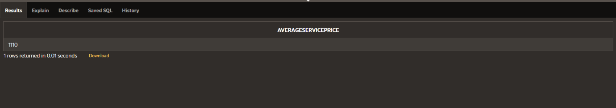

Average

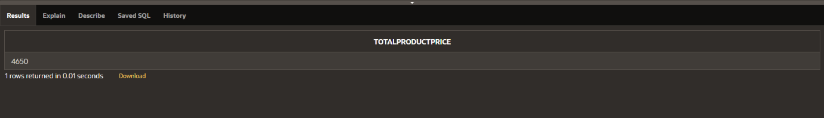

Sum

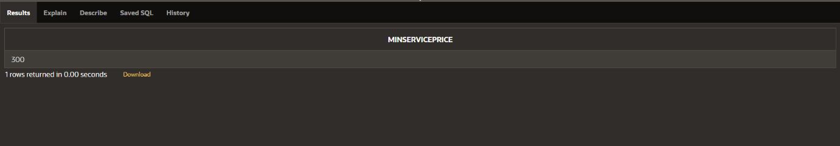

Minimum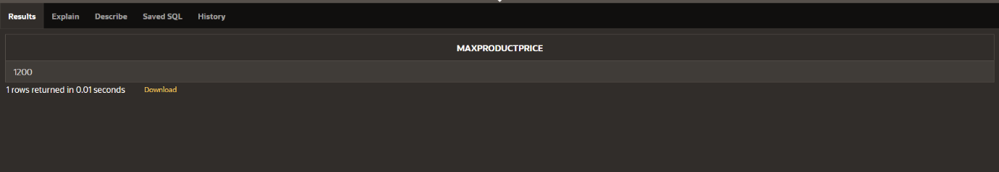

Maximum 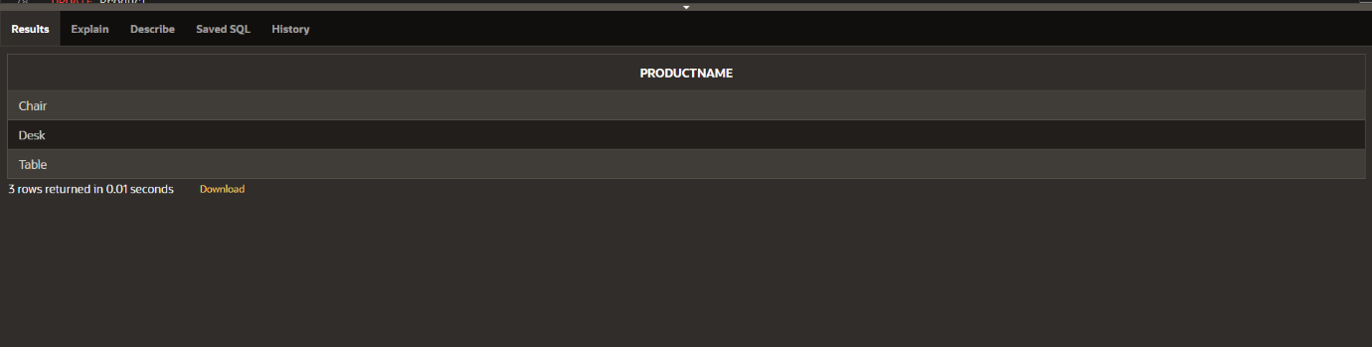

AND and ‘=’ operator

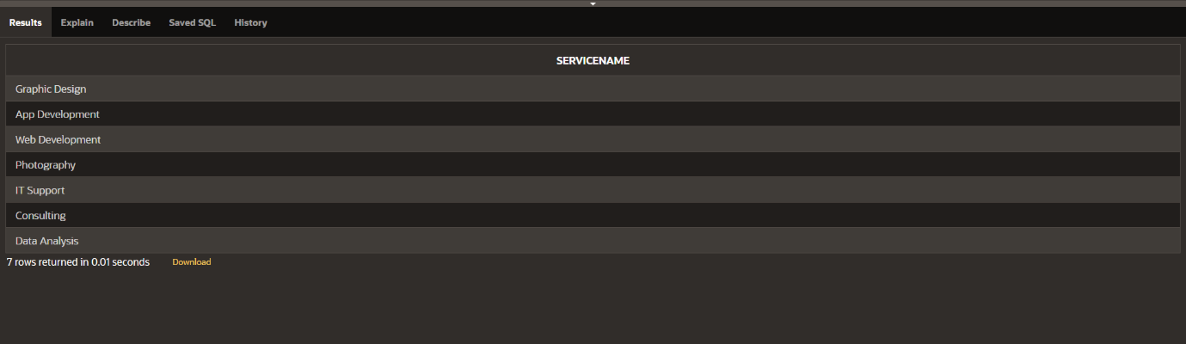

‘!=’ Operator

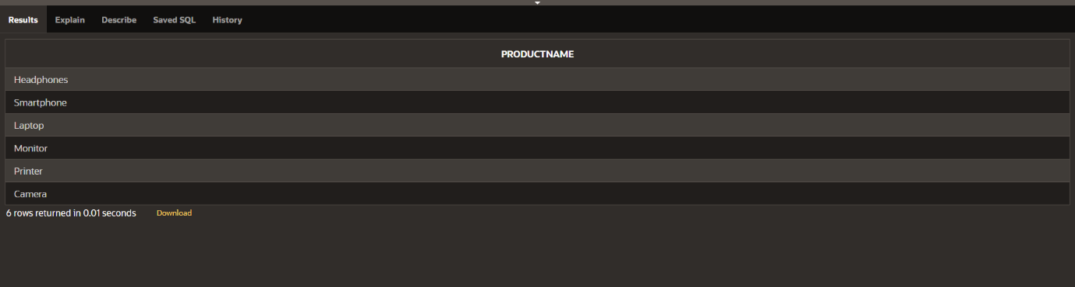

OR operator

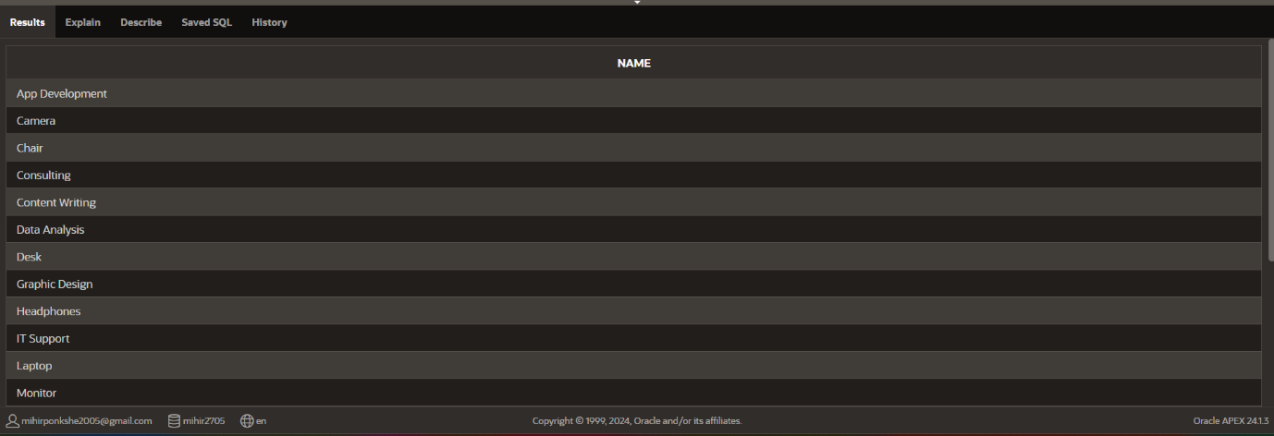

Union operator